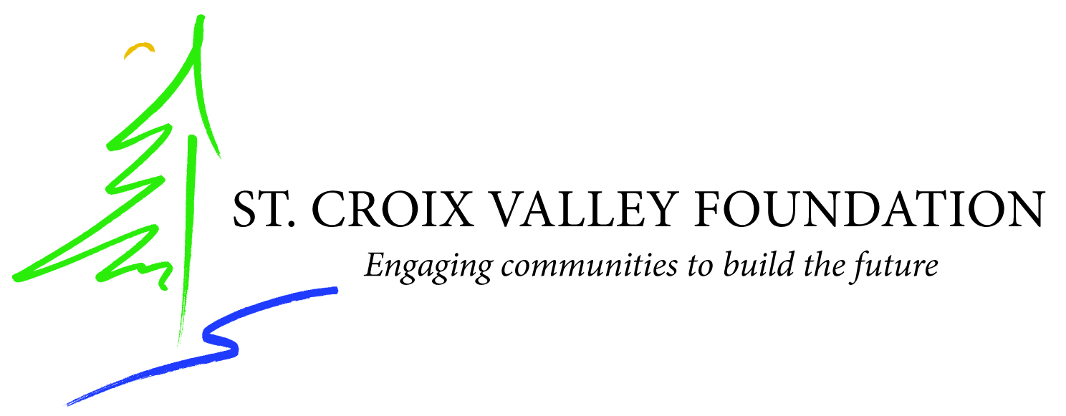
St. Croix Valley Foundation
Proposal Narrative
Please answer these questions in your narrative.
Include any other pertinent information that you deem important.
Please limit your narrative to three pages total.

- Introduction
Introduce yourself, including your background. Tell us about the music program at your school.

- Description
What is your project? Discuss the specific activities.
What is the plan and the timeline of the project?
What are the goals you hope to achieve?
If other staff or outside artists are involved, discuss their background and why they were chosen.

- Need and Impact
Why is this project needed in your school?
How will this project impact your students and the broader community?

